ICT-3200, Industrial Visit Report, Part-1
Walton Hi-Tech Industries PLC

Department of Information and Communication Technology
Mawlana Bhashani Science and Technology University

Contents
- Student Information 2
- Introduction 2
- Objectives 2
- Company Overview 2
- Departments Visited 3
- Technologies Observed 3
- ICT Applications 4
- Learning Outcomes 4
- Challenges Observed 4
- Recommendations 5
- Conclusion 5
Appendix 5
1. Student Information
Name: Kuldip Saha Mugdha
Student ID: IT22018
Session: 2021–22
Semester: 3rd Year, 2nd Semester
Date of Visit: 21st July, 2026
Submission Date: 3rd August, 2026

2. Introduction
The industrial visit to Walton Hi-Tech Industries PLC was conducted as part of the ICT-3200 course to provide practical exposure to real-world industrial environments. The purpose of this visit was to observe modern manufacturing systems, industrial automation, and ICT applications used in large-scale production. This visit helped students understand how theoretical knowledge is applied in industry and provided insights into professional working environments.

3. Objectives
- To understand modern manufacturing technologies.
- To observe industrial automation systems.
- To learn about quality control processes.
- To study production planning and supply chain management.
- To relate academic knowledge with industrial practices.

4. Company Overview
Walton Hi-Tech Industries PLC is one of the leading manufacturing companies in Bangladesh. It was established in 1977 and has grown into a globally recognized brand.
The company produces over 200 types of products, including refrigerators, mobile phones, laptops, and other electronics. Approximately 70% of their production is focused on refrigeration products. Walton earns around 590 million USD annually and exports products to more than 50 countries, including India, Sri Lanka, Nepal, Bhutan, and Singapore.
The factory area covers around 800 acres with 34 buildings, making it one of the largest industrial facilities in the country. The company employs more than 30,000 workers, including around 800 engineers from public universities and 4,000 diploma engineers.
Walton is certified by international standards such as BSCI and ISO. The company also provides various facilities and benefits for its employees, ensuring a professional and supportive working environment.

5. Departments Visited
During the visit, several important departments were observed, including:
- Refrigerator Manufacturing Section
- Printed Circuit Board (PCB) Manufacturing Section
- ICT Department
- Server Room
In the Refrigerator Manufacturing Section, processes such as thermoforming, HIPS-based container preparation, bending and hole piercing, and helium leak testing were observed, ensuring product strength and quality. In the Printed Circuit Board (PCB) Manufacturing Section, stages like copper plating, drilling, dielectric layering, screen printing, and visual inspection were carried out to ensure proper electrical functionality. The ICT Department utilizes various software systems and automation tools for efficient operations. The Server Room manages centralized data, system control, and network operations supporting the entire industrial system.

6. Technologies Observed
The following technologies were observed during the visit:
- Automated manufacturing systems
- Conveyor-based production processes
- Helium leak detection systems
- Screen printing machines
- Advanced testing and inspection systems
- Server-based infrastructure for data management

7. ICT Applications
Walton has a highly advanced ICT infrastructure. The ICT department operates through an internal portal: www.ictportal.walton.com.
Key ICT applications include:
- Administrative Automation (32 different software systems)
- Manufacturing Automation Systems
- Human Resource Management System (HRMS)
- Walton Customer Relationship Management (WCRM)
- Enterprise Business Suite (EBS), an international software solution
Professional teams work in different ICT sectors to maintain efficiency, data security, and smooth operations.

8. Learning Outcomes
From this industrial visit, several important lessons were learned:
- Understanding of real-life manufacturing processes
- Knowledge of industrial automation and ICT integration
- Experience of large-scale production systems
- Insight into professional work environments
- Awareness of how industries maintain quality and efficiency

9. Challenges Observed
Some challenges and limitations observed include:
- Complex processes that require high-level maintenance
- Dependency on advanced machinery and automation
- Need for continuous monitoring and skilled manpower
- High operational costs for maintaining large-scale production

10. Recommendations
Based on the observations, the following recommendations can be suggested:
- Further enhancement of automation systems
- Regular training programs for employees
- Improvement in monitoring systems for better efficiency
- Continuous upgrading of ICT infrastructure
- Strengthening cybersecurity measures

11. Conclusion
The industrial visit to Walton Hi-Tech Industries PLC was highly informative and beneficial. It provided practical knowledge about industrial operations, automation, and ICT applications. The visit successfully bridged the gap between academic learning and real-world industry practices. Overall, this experience will be valuable for future professional development.

Appendix
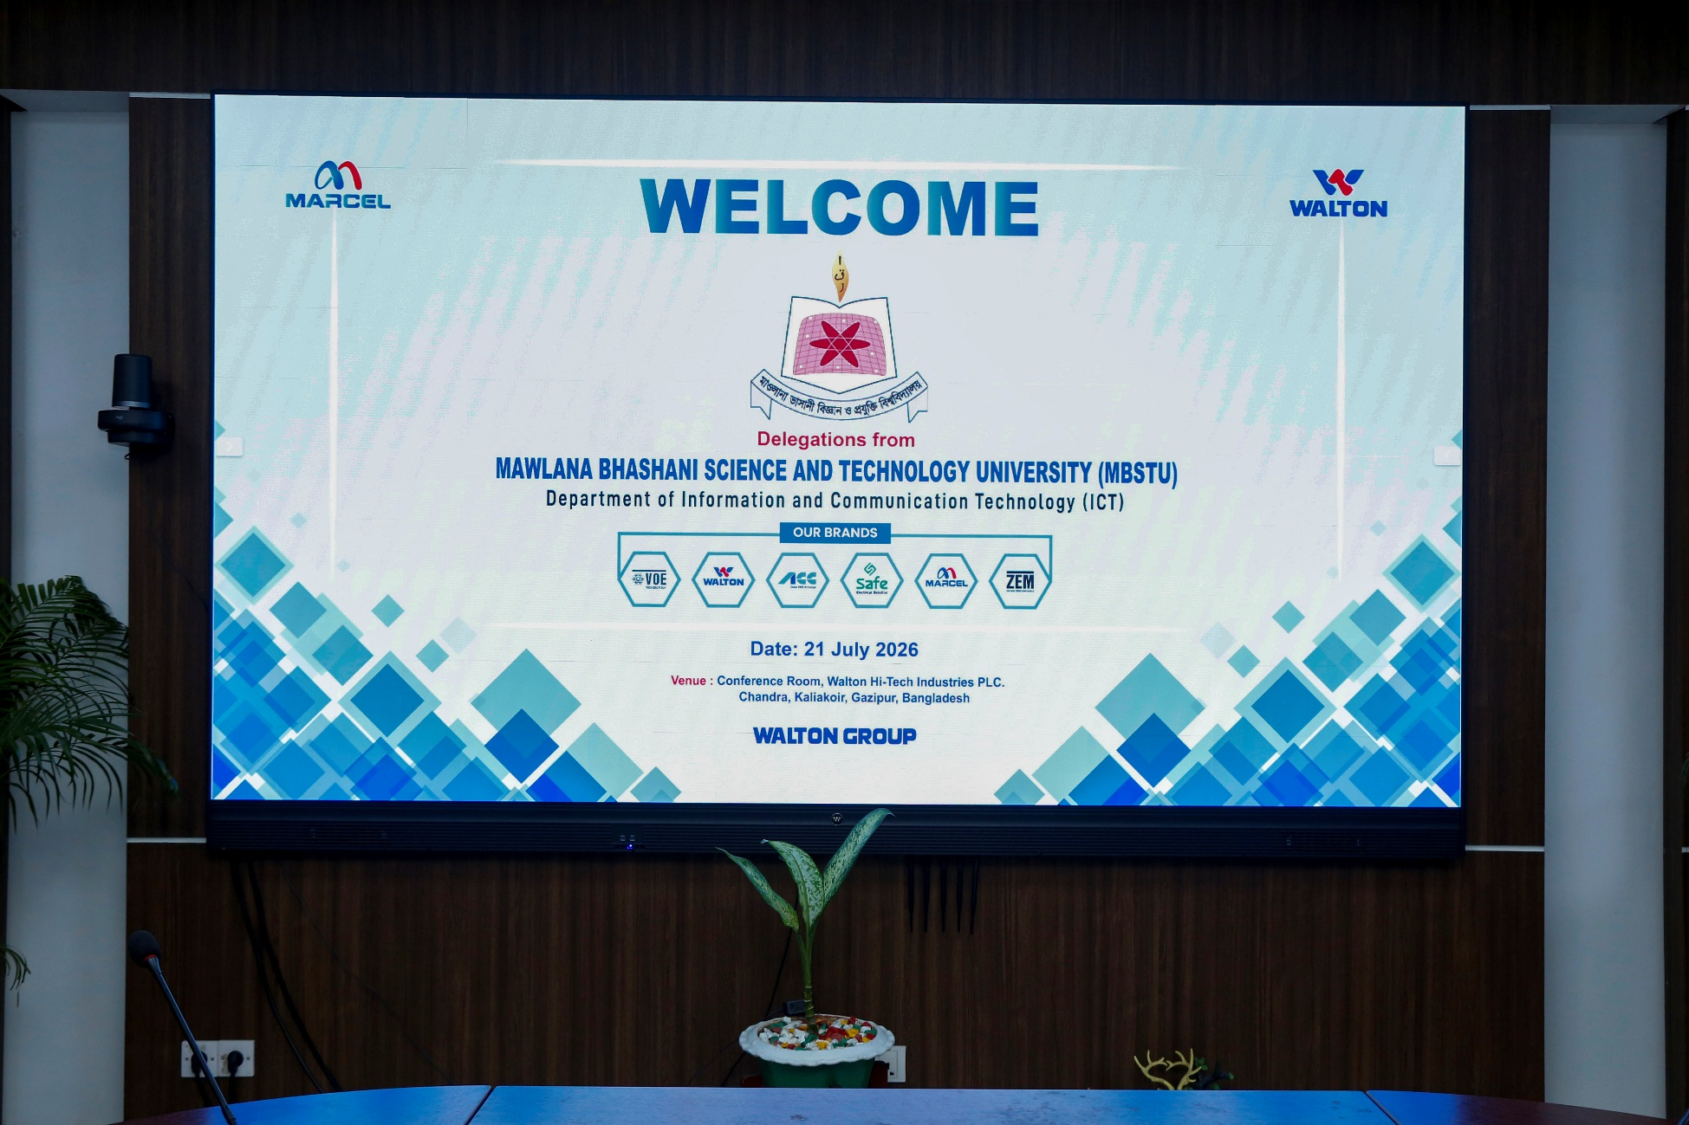
Warm Welcome From Walton
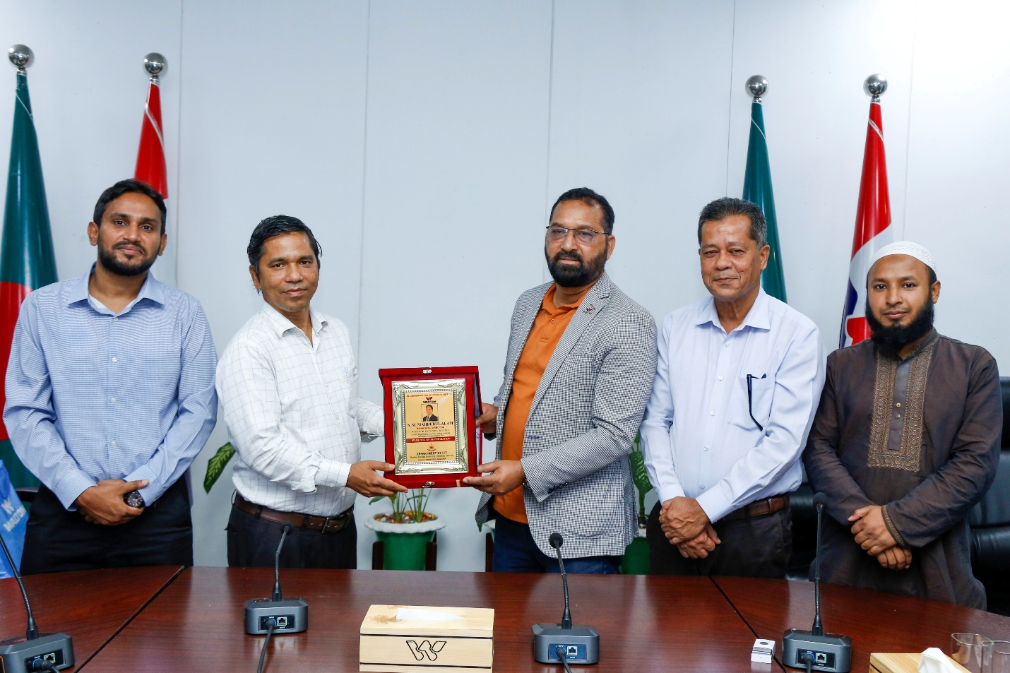
Honoring Factory Head, MD Yusuf Ali Sir

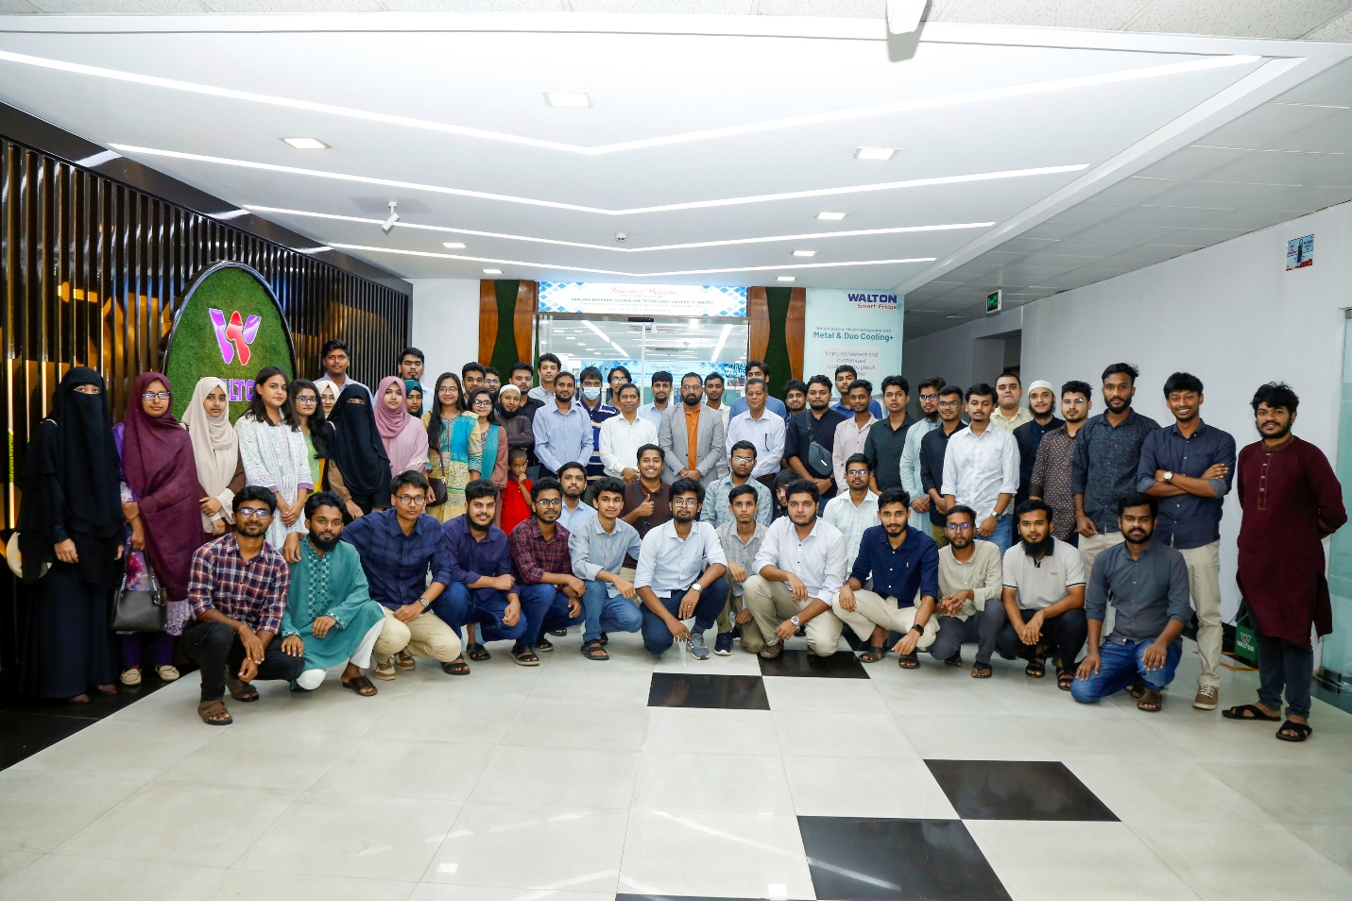
Group Photo of this Industry Visit at Walton Hi-Tech
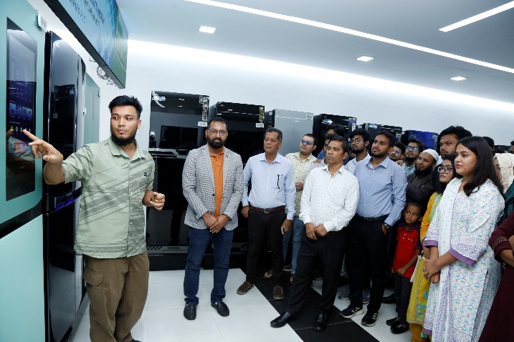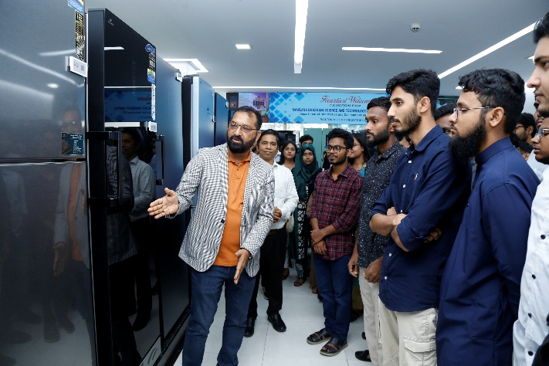
Showroom Overview

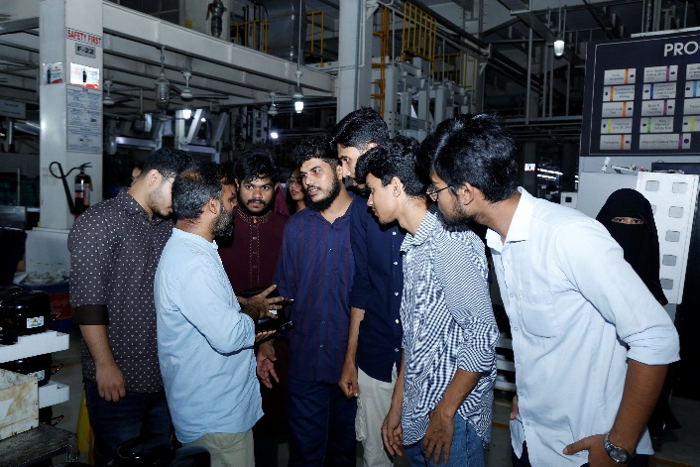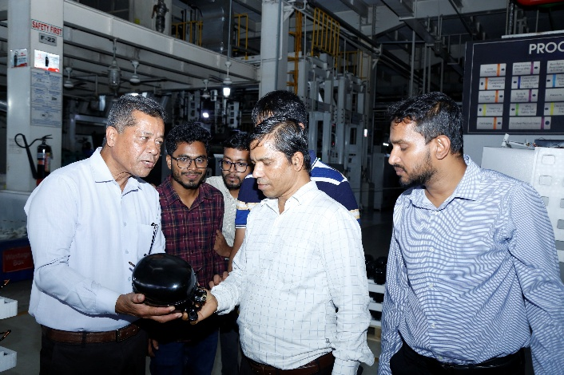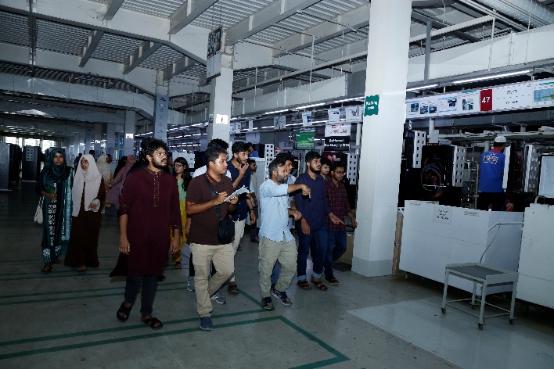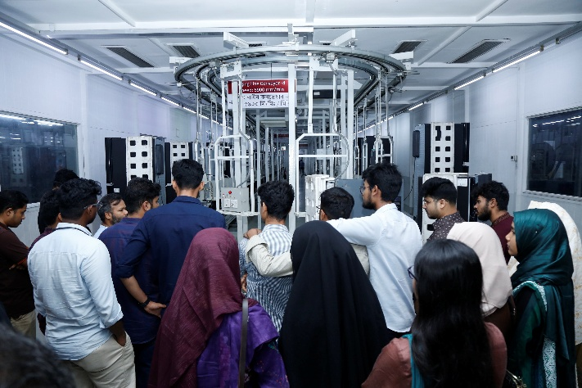
Refrigerator Factory Overview

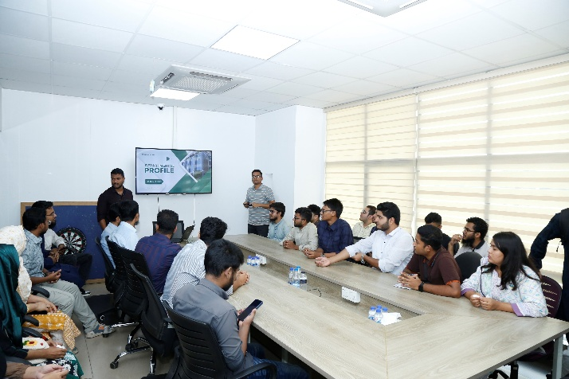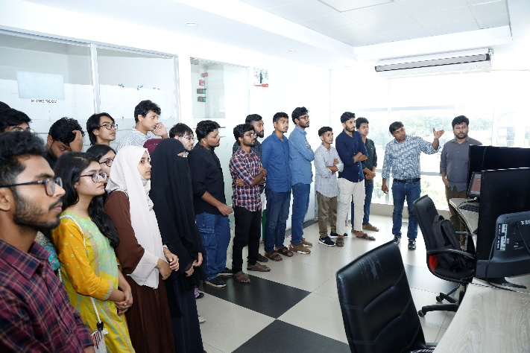
Visit At ICT Department

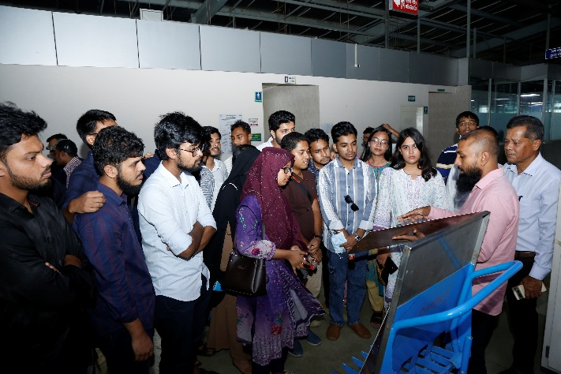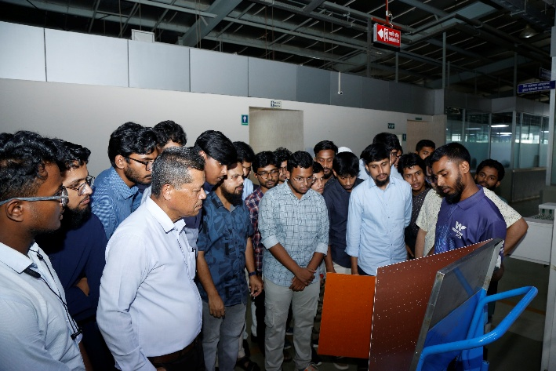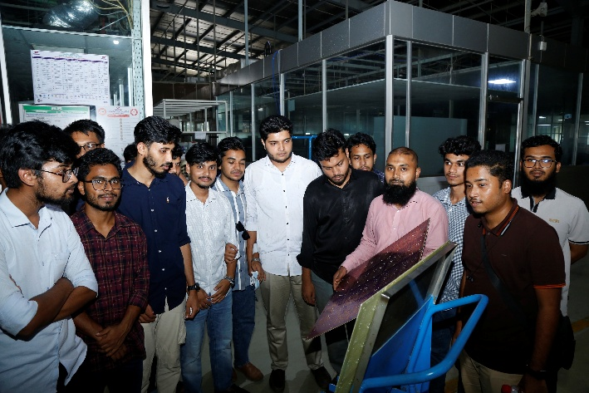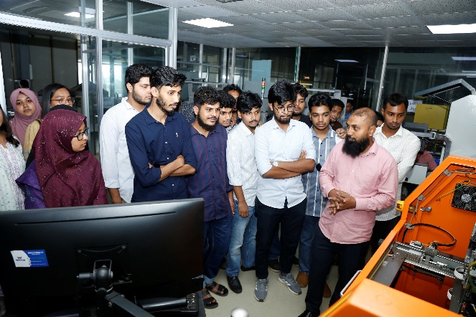
Visit at Circuit Board Factory

